COVER LETTER

Respected Hiring Manager,

I MD SABIR ALAM would like to express my interest in working with your company as a mechanical engineer. The opportunity to be employed by such a prestigious company like this which accommodates my professional interests would be an immense stepping stone for my future.

I have two Two years five months experience in piping mentainence, pipe fabrication & Erection in INDOFIL INDUSTRIALS LTD DAHEJ, BHARUCH, Till.... Under the contract of Shree SS Engineering & Industrial service ,Jolva P- 33 PLANT project SRF LIMITED DAHEJ , GUJRAT Under the contract of SUNRISE PROCESS PIPING,DAHEJ,& Structure Fabrication, Equipment Insulation and Erection of Narmada Dam Project as a Mechanical Engineer (Mechanical) at CMU, WRD Bhopal on contract of SSQ ALI ENGINEERING WORKS. I believe that my education, skill, eagerness & enthusiasm for the discipline make me a qualified and valuable candidate. I would love to work with your company.

I have completed Bachelor of Engineering in Mechanical from Gwalior Institute of technology and Science Gwalior, Rajiv Gandhi Technical University in 2016 with 7.37 CGPA.

I am jobbing devoted, punctual and self-motivated person. I have ability to work as an individual and also as part of a team. I am a firm believer in the importance of being well-rounded and taking on new challenges, and I believe these shows though in my assortment of both academic and project work.
I am available for interview at any time. Thank you for taking the time to read this letter and I look forward to hearing from you in the near future.

Regards,

MD SABIR ALAM
B.E. Mechanical
E-mail ID: - sabirmtpie@gmail.com
Cell Phone No: - + 91-8839052012,+91 7041161990

RESUME
MD SABIR ALAM
(B.E. Mechanical Engineer)
Email: sabirmtpie@gmail.com
Mob No: 91-8839052012, +917041161990

CAREER OBJECTIVES:

A young and dynamic engineer with experience in fabrication and erection willing to join an organization where growth is a way of life and seeks a position which will offer me all kind of challenges to exploit my skills fully and improve them.

EDUCATIONAL QUALIFICATION:

- B.E in Mechanical Engineering from Rajiv Gandhi Technical University, Bhopal(2012-2016) With 7.37 CGPA
- Senior Secondary from Bihar School Examination Board, Patna (2009-2011) with 63.2 %.
- Secondary School from Bihar School Examination Board, Patna (2009) with 72.4 %
WORK EXPERIENCE: Total: - 2.5 Years

I am working in INDOFIL INDUSTRIALS LTD DAHEJ .,BHARUCH,Under the contract of Shree S S Engineering & Industrial service.I also Worked in SRF LIMITD DAHEJ (GUJRAT) under the contract of SUNRISE PROCESS PIPING, JOLVA DAHEJ & SSQ ALI ENGINEERING WORKS BHOPAL. As Mechanical engineer for the Narmada Dam Project of CMU, WRD BHOPAL.

JOB DESCRIPTION:

Structure:-
- Preparation of Fabrication and erection schedule to meet the target with in planned time frame.
- Men power handling and stage inspection of structures at site.
- Certifying the sub-contractors bills and coordinating for preparing the client bill.
- Responsible for the implementation of safety standards at the project site by ensuring that all relevant norms are employed effective.
- Quality inspection of column alignment and welding inspection.
- Distribution of work among workmen according to their skill.
- Day to day Co-Ordination and regular inspection activities with third party and client.
- Knowledge of Plan Drawing, Fabrication Drawing, PEB Drawing & Nozzle Orientation Drawing.
- Documentation, DPR, Material reconciliation, quality check lists, Preparing Punch list
Piping:-
- Entire Piping Inspection during the Shop Fabrication and Site Fabrication.
- Verification of Materials, material receiving inspection prior to release for fabrication.
- Identifying the test medium to be used for hydro test for piping lines in the test package.
- Knowledge of P&ID, G.A Drawing and Isometric Drawing.
- Knowledge of IS, ASME, API Codes & Standards.
- Knowledge ofFRP, HDPE and PPE Lines materials .
- All types of piping maintenance
- Equipment:-
- Inspection of Static equipment during and after erection.
- Equipment foundation elevation inspection.
- Inspection of equipment elevation, verticality and verify foundation and equipment centre lines.
- Bolt tightening inspection of Structural steel, plant forms, stairs walkways etc.
- Equipment Alignment, Inspection and Validation.

- AWARD:-
I am President awarded by P. D. S. PATIL in 2010

TRAINING:
- Vocational Training on “THERMAL POWER PLANT’’ at Patratu , Ramgarh ,Ranchi(Jharkhand) 16 Jan-30Jan 2015
- Vocational Training on “ BHEL”at Jhansi (UP 16Jun-29Jan 2015
PROFESSIONAL REFERENCE:

- Name: Syed Asif Ali
Designation: Construction Manager
Company’s ALI NGINRING WORKS, BHOPAL
Name: Syed Saud Ahmad
Designation: Project Engineer
Company: SSQ ALI NGINRING WORKS, BHOPAL.

TECHNICAL SKILLS
- M S Office
- MS Xcel
- Auto-Cad
- C,C++
- Basic Knowledge of Networking
PERSONAL INFORMATION:

Date of Birth : 10thDecember, 1993
Father’s name : Mr. Waseel Ahmad
Marital Status : Single
Language Proficiency : English, Hindi, Urdu, aArbic, Persian
Hobbies : Volunteer work, solving logical questions, listening Music
Strength : Creativity, Accuracy, Analytics, Adapting to changing circumstances
Permanent Address : Vill:-Garhwa, PS-Majhaulia, Dist-West Champaran, (Bihar)
Pin Code-845454

DECLARATION:

I certify that all the information above is correct, and references are available if needed.

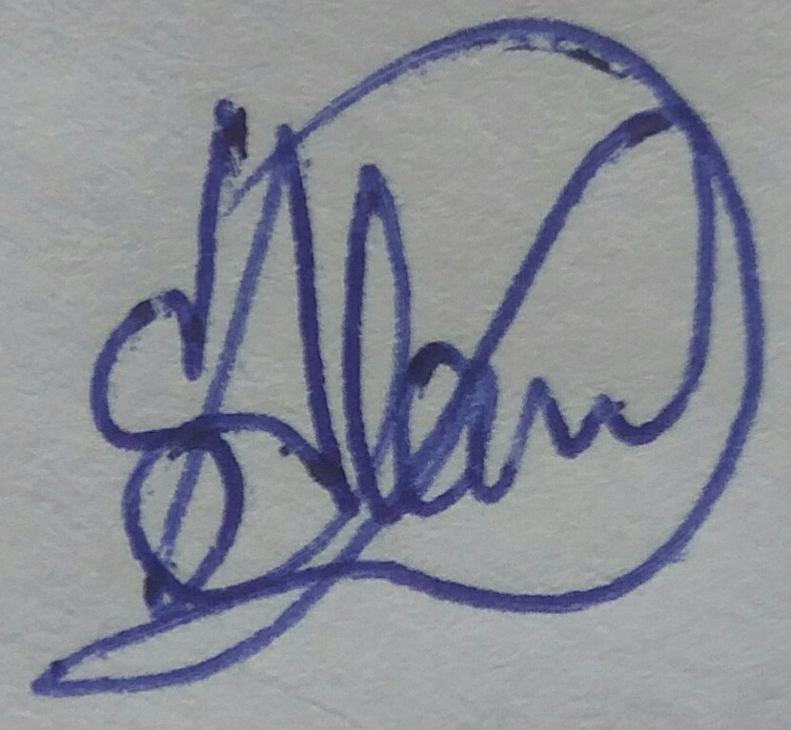
Date:1 APRIL, 2018
Place:Dahej, Gujarat.

